CYBERSECURITY TOOLS · WEEKLY LEARNING TRACK
Nmap Reference Documentation
Module 6: Timing Templates and Performance Tuning

Prepared by Emmanuel Aidoo
Kali Linux · Nmap 7.98
September 21, 2026

Contents
1 Minimum Rate Tuning (min rate option) 3
2 Aggressive Timing via Zenmap (T4 option) 4
3 Insane Timing (T5 option) 5
4 Key Takeaways 6

In this module, I look at how Nmap's speed and reliability trade off against each other. I force a minimum packet rate, step up through the built in timing templates, and see what happens to accuracy at the fastest settings.
A quick note before I start: I am leaving the dash character out of this entire document, even inside the example commands. Nmap normally expects that symbol right before each option name, so if I copy a command below to actually run it, I need to add that symbol back in front of every option.

1 Minimum Rate Tuning (min rate option)
The min rate option tells Nmap never to send probe packets slower than a number I give it, per second, overriding its usual congestion control pacing. I used it to trade away some of Nmap's automatic caution for raw speed, since I already trust this network to handle it.
● ● ●
$ nmap min rate 1000 173.230.138.70
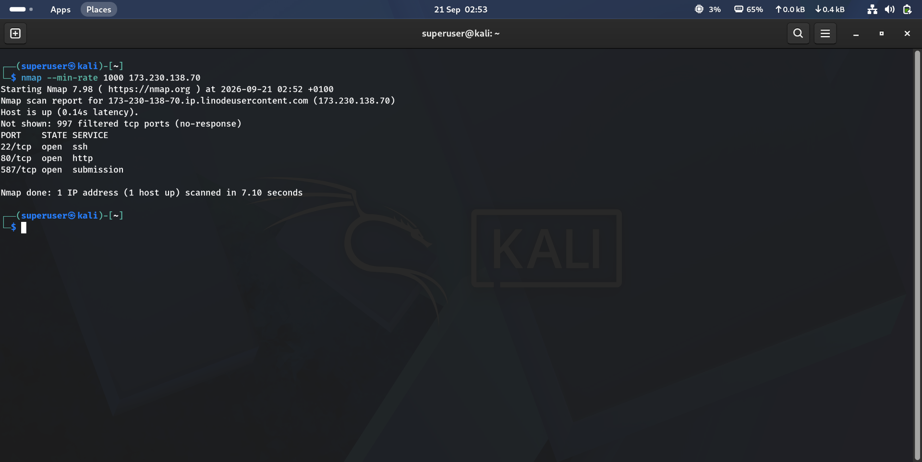
Figure 1 · the scan where I forced a 1000 packets per second minimum send rate against 173.230.138.70
Result summary
Port | State | Service
22/tcp | open | ssh
80/tcp | open | http
587/tcp | open | submission

Observation
I got 997 of 1000 ports filtered, with the same three ports open as every earlier scan of this host, but the whole thing finished in 7.10 seconds. That is close to the fastest result I have seen against this target across every module so far, purely from forcing the packet rate rather than changing the scan type.

2 Aggressive Timing via Zenmap (T4 option)
Zenmap is Nmap's official graphical front end. It is the same scan engine and the same output, just a GUI wrapped around the command line. For this run I used the T4 template (Aggressive, one step below the fastest one) combined with the sV and A options for full version detection, OS attempts, scripts, and a traceroute.
● ● ●
$ nmap sV T4 A v 173.230.138.70
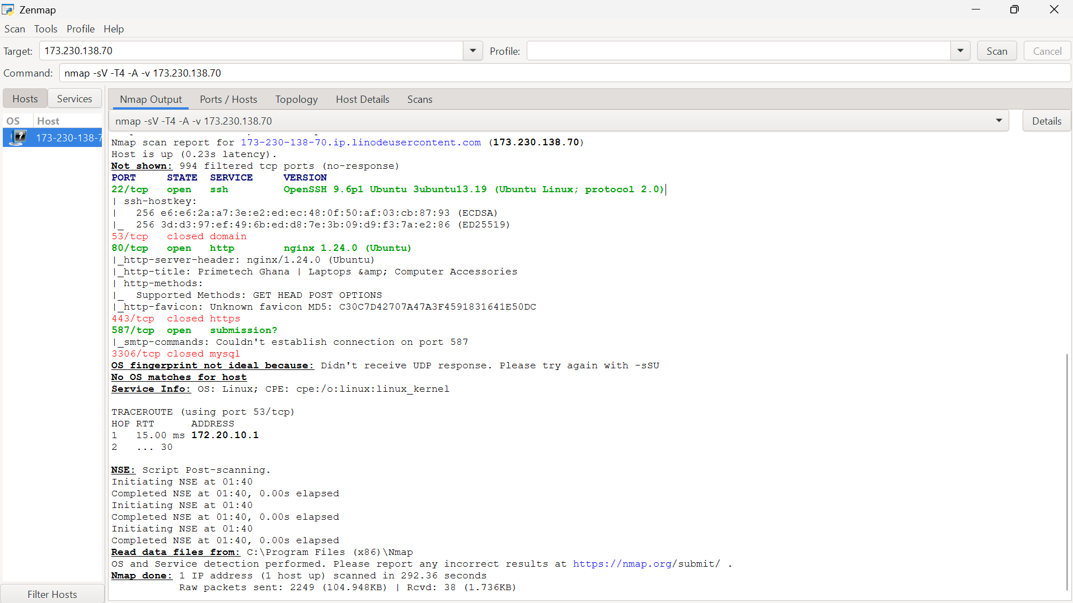
Figure 2 · the intense T4 scan with full version detection that I ran in Zenmap
Result summary
Port | State | Version detected
22/tcp | open | OpenSSH 9.6p1 Ubuntu 3ubuntu13.19 (protocol 2.0)
53/tcp | closed | none
80/tcp | open | nginx 1.24.0 (Ubuntu); title: Primetech Ghana
443/tcp | closed | none
587/tcp | open | submission? (unconfirmed)
3306/tcp | closed | none

This time the banners came through
Every earlier scan of this host, back in Module 5, reported ports 22, 80, and 587 as tcpwrapped: open, but with no identifiable service. Here, the exact same ports resolved to real version strings, OpenSSH 9.6p1 and nginx 1.24.0. Nothing about the target changed. What is different is that I combined the sV option explicitly with the A option this time, and Zenmap's default verbose setting ran a fuller probe set. It is a reminder that tcpwrapped is not necessarily permanent. A differently configured scan against the same host can still pull a real banner where a previous one could not.

The traceroute also looked different from earlier modules. Hop 1 landed on 172.20.10.1 at 15.00ms, an intermediate router rather than the target itself, and hop 2 timed out. My total scan time was 292.36 seconds, by far the longest in this module, which reflects how much more work the sV, A, and NSE scripting options do per port compared with a plain scan.

3 Insane Timing (T5 option)
The T5 template is Nmap's fastest and least patient timing setting: minimal delays between probes, aggressive parallelism, and short timeouts. It trades reliability for raw speed, and this scan showed me exactly what that trade costs.
● ● ●
$ nmap T5 A 173.230.138.70
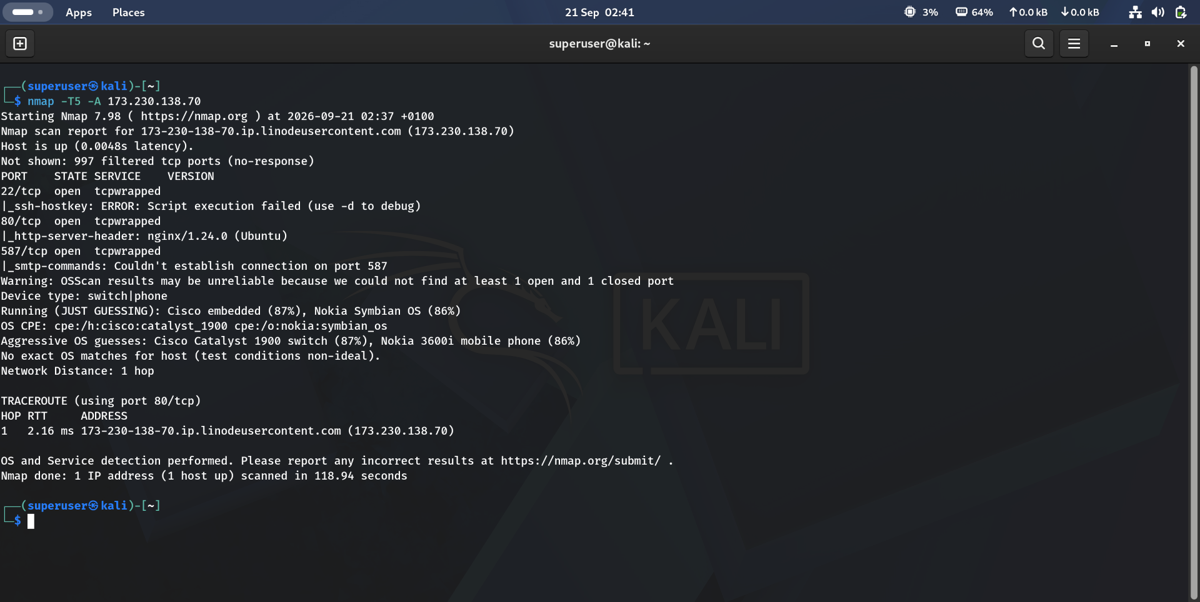
Figure 3 · the insane speed T5 scan that degraded my OS detection accuracy
What I got wrong with T5
Aspect | Result
Ports | The same 3 open (tcpwrapped) as my prior A option runs; port scanning itself held up fine
OS detection | “Warning: OSScan results may be unreliable because we could not find at least 1 open and 1 closed port”
OS guesses | Device type: switch or phone. “JUST GUESSING”: Cisco embedded (87%), Nokia Symbian OS (86%); the aggressive guesses named a Cisco Catalyst 1900 switch and a Nokia 3600i mobile phone
Scan time | 118.94 seconds, faster than my Zenmap run, but at a real accuracy cost

Speed bought me nothing here, and cost accuracy
I already confirmed in Section 2 that 173.230.138.70 is a Linux server running nginx and OpenSSH. The T5 guesses, a Cisco switch, a Nokia phone, are not just wrong, they name a completely different class of device, and Nmap itself flagged the result as unreliable rather than presenting it as fact. This is the clearest illustration in the module of the balance between timing and accuracy. OS fingerprinting depends on responses that come back at precisely timed intervals, and the T5 template's aggressive pacing did not leave room for me to collect them cleanly.

4 Key Takeaways
- The min rate option forces a floor on how fast packets get sent, letting me trade some of Nmap's built in congestion caution for a faster scan when I trust the network.
- Zenmap is the same Nmap engine behind a GUI. It is useful for building and re running commands visually, not a different scanner.
- tcpwrapped is not a fixed verdict for a host. The same port that stonewalled one scan configuration handed over a full version banner, OpenSSH, nginx, under a different one.
- Timing templates run from T0, the most paranoid setting, up to T5, the most insane one. Higher is not strictly better, since faster pacing can starve features that depend on accuracy, like OS fingerprinting.
- When Nmap flags its own OS guess as unreliable, I trust that warning over the guess itself. Wildly wrong guesses about device class, like a Linux web server misread as a Cisco switch, are the direct result of timing that is too aggressive, not a genuinely ambiguous host.

